ACKNOWLEDGEMENT

INDEX

INTRODUCTION

ABOUT NETWORKING(2)

ABOUT PROJECT(1/2)

PROJECT DETAILS:

In this project we will be designing network for university in a simple manner. The basic requirements that we will be covering are as follows:

* Network access for departments
* Network access for students
* Network access for staff members
* Special connection to administrative department, reception and chancellor or chairman
* Network access for hostellers
* Network access for guest or parents coming to visit their wards
* Network access for library

DEVICES USED IN THE NETWORK CONNECTIVITY:

1. ROUTERS
2. SWITCHES
3. CABLES
4. SEREVRS (DHCP, SMTP, HTTP, DNS)
5. COMPUTERS AND LAPTOPS

Now we will be elaborating some points about these devices and their uses in the project:

* ROUTERS
* SWITCHES
* CABLES
* SEREVRS (DHCP, SMTP, HTTP, DNS)
* COMPUTERS AND LAPTOPS

PROJECT DESIGN:

MODULES:

1. ADMIN BLOCK OR ISP NETWORK

This is the root of the whole network design from where the connections will be made to all the sub-modules of the network. The features of the module consist of:

* Servers that includes HTTP server for internet connectivity.
* SMTP server for email services
* DHCP for providing allocating dynamic ip address to the devices.
* It also includes DNS server that servers as the pool for IP address allocation

1. DEPARTMENT

The department module will consist of all the departments of the university that are:

* COMPUTER SCIENCE
* ELECTRICAL
* MECHANICAL
* AERONAUTICAL
* CIVIL

1. ADMINISTRATIVE BLOCK

This module is the heart of university where all the administration work is carried out. It includes both wired (for department P.C) as well as wireless (for personal laptops) connection.

1. LIBRARY

The library module will have wired connection for the library staff and for some P. C’s accessible by students.

It will also contain wireless connection.

1. GUEST ROOM

The guest room will have connection for the parents meeting their wards and for visitors.

1. HOSTEL

The hostel module contains both girls and boys’ hostel.

Wired connections will be provided for receptions and wardens computer.

Students will be provided with wireless connection for their laptops.

FLOWCHART

SCREENSHOTS:

1. It is the main ISP SERVER consisting of HTTP and SMTP server.

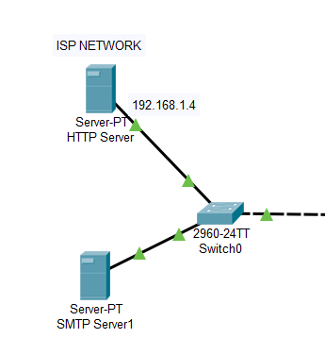

1. This is the admin module

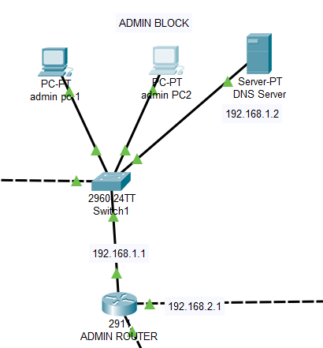

1. This is administrative module.

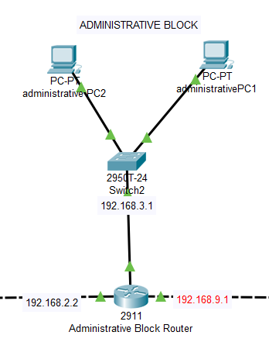

1. These are the domains that will be active in the whole university network.

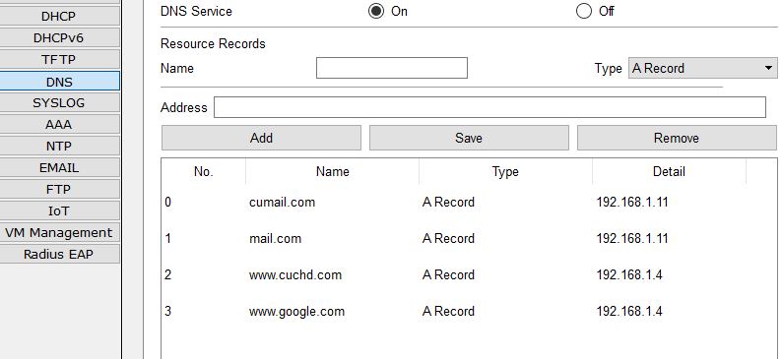

TEST CASES:

1. The ping here is done to the admins P.C which is successful.

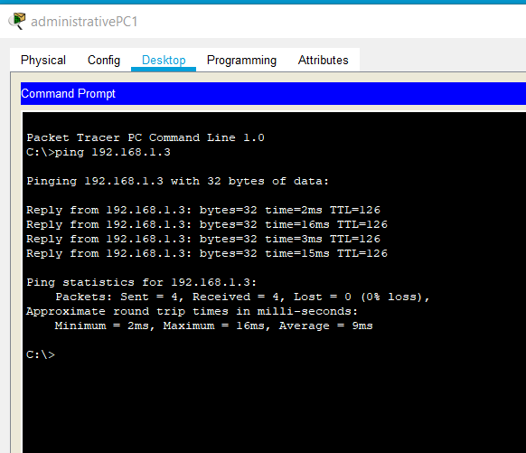

1. As we can see that the internet is active on the computers and the results for the search is successful.

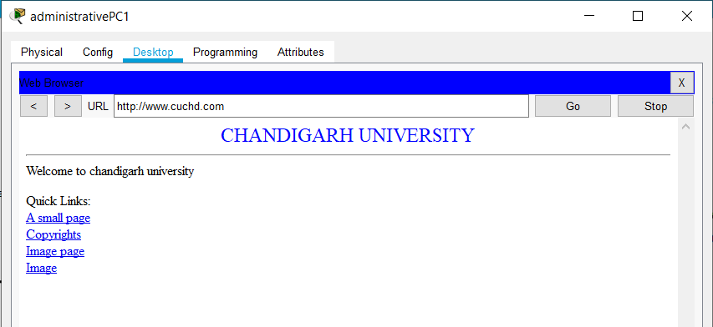

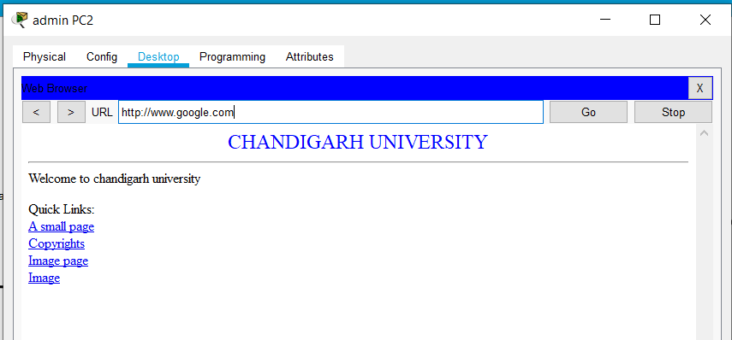

1. Now we are configuring thr SMTP protocol by sending thr mail on the admnstratives computers.

* In the below picture the email is being composed.

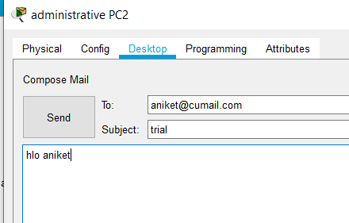

* Now from PC2 the mail has been successfully received on PC1 .

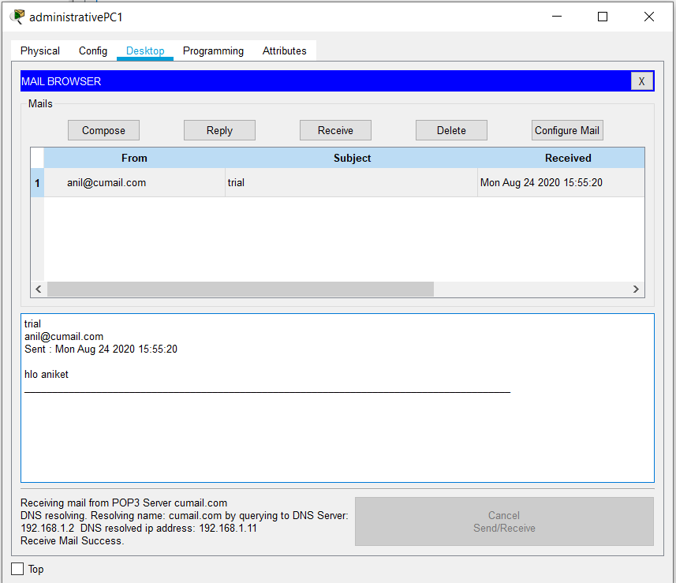

1. Since we are using the DHCP protocol so dynamic allocation of IP addresses will be done.

Therefore, in the picture we can see the message “DHCP request successful”.

